**Phase II: Design Report**

Joseph Schauer

Suman Islam

Qizhi Zhao

Weicheng Huang

# **Introduction**

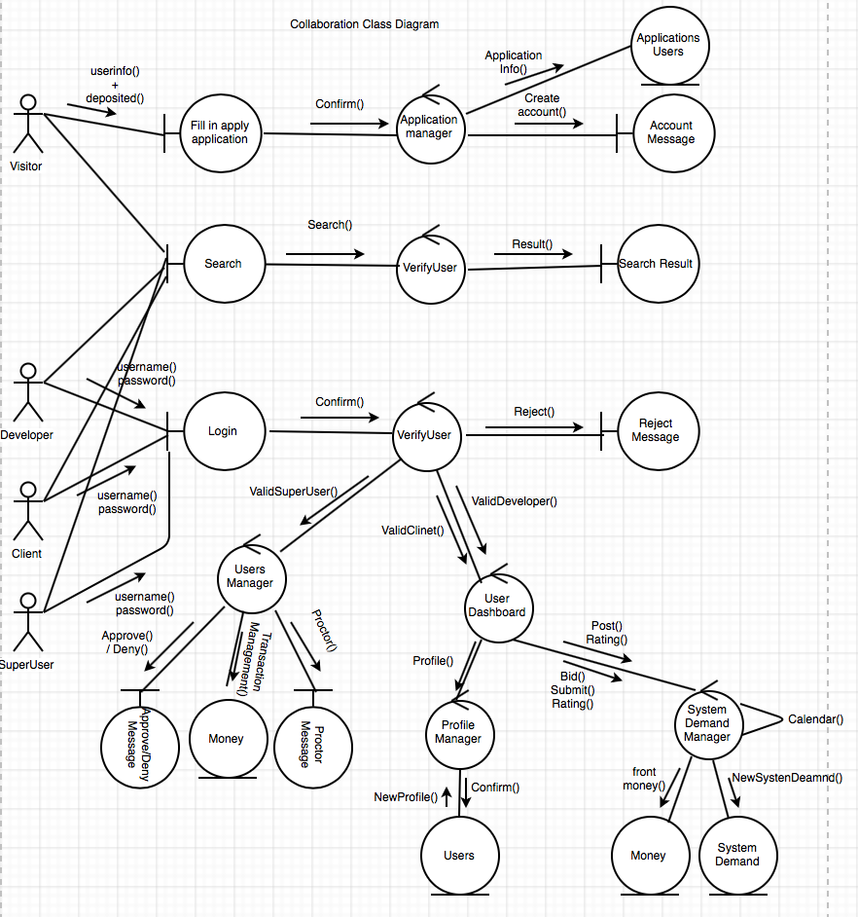

Contents

1. Introduction 2

2. All use cases 3

2.1.1 Apply for account (Collaboration Diagram) 3

2.1.2 Apply for account (Petri Net) 3

2.2.1 View/search information (Collaboration Diagram) 3

2.2.2 View/search information (Petri Net) 4

2.3.1 Post Demand (Collaboration Diagram) 4

2.3.2 Post Demand (Petri Net) 5

2.4.1 Bid Project (Collaboration Diagram) 5

2.4.2 Bid Project (PetriNet) 5

2.4.3 Submit Project (Collaboration Diagram) 6

2.4.4 Submit Project (Petri Net) 7

2.4.5 Manage User (Collaboration Diagram) 7

2.4.6 Manage User (Petri Net) 8

3. E-R diagrams for the entire system 9

4. Detailed design: 10

5. System screens: 14

6. Minutes of group meetings 17

7. Minutes of group meetings 17

# **All use cases**

## Apply for account (Collaboration Diagram)

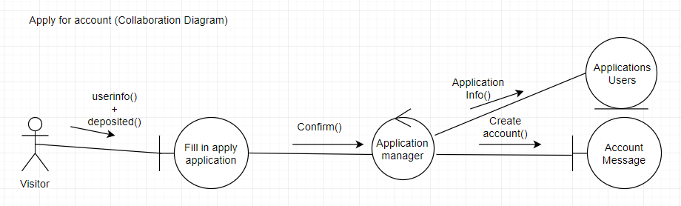

## Apply for account (Petri Net)

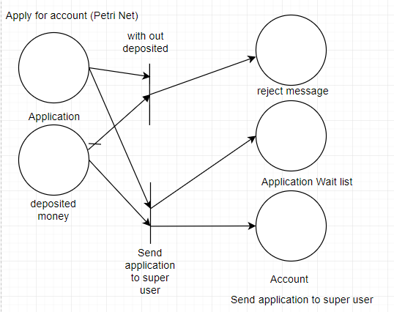

## View/search information (Collaboration Diagram)

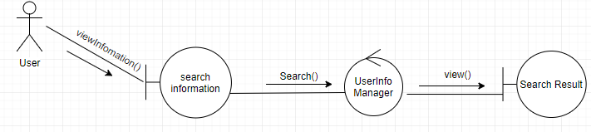

## View/search information (Petri Net)

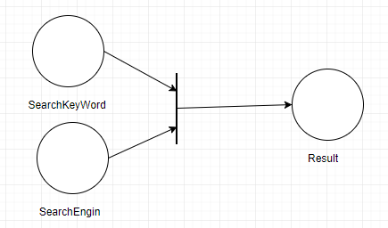

## Post Demand (Collaboration Diagram)

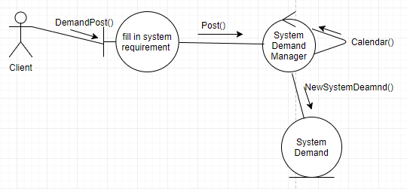

## Post Demand (Petri Net)

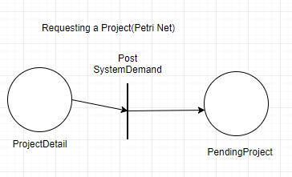

## Bid Project (Collaboration Diagram)

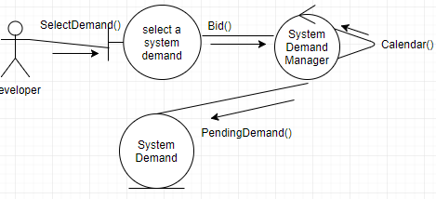

## Bid Project (PetriNet)

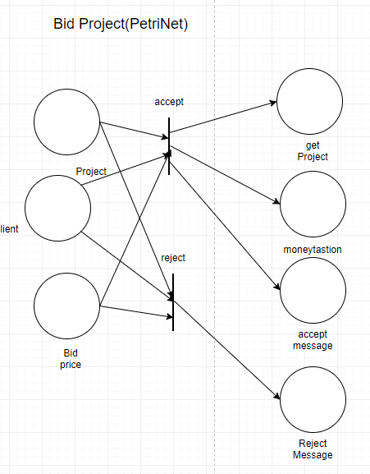

## Submit Project (Collaboration Diagram)

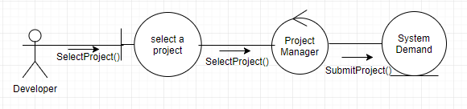

## Submit Project (Petri Net)

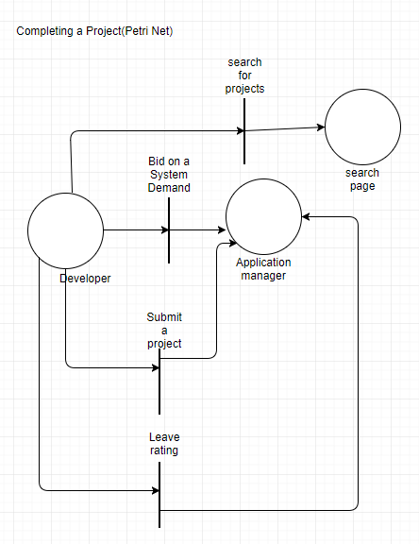

## Manage User (Collaboration Diagram)

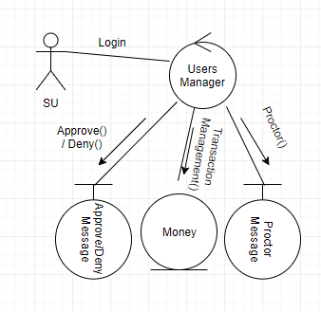

## Manage User (Petri Net)

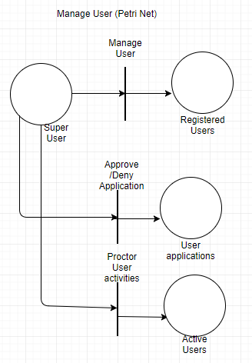

# **E-R diagrams for the entire system**

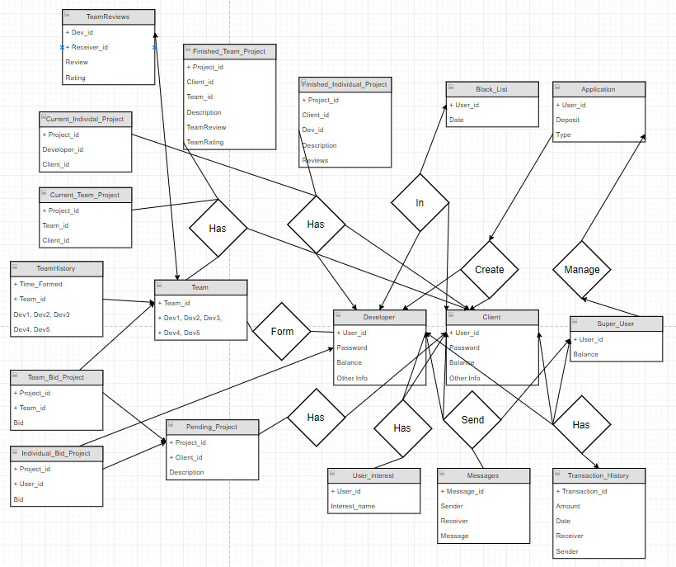

# **Detailed design:**

Class:Gateway:

__init__():

self.connect to database

self.coursor for connect

check_backlist(user_id):

if user.id in backlist table:

True

else

False

developer?(user_id):

if user.id in develop table:

True

else

False

client?(user_id):

if user.id in Client table:

True

else

False

superUser?(user_id):

if user.id in SuperUser table:

True

else

False

matchPassword(user_id, password):

if match

return True

else

return False

wirteToDeveloperTable(user_id, password, other):

wirete to developer table(user_id, password, other

wirteToClientTable(user_id, password, other):

wirete to Client table(user_id, password, other)

wirteToSuperUserTable(user_id, password, other):

wirete to SuperUser table(user_id, password, other)

updateDeveloperTable(user_id, password, other):

updateDeveloperTable(user_id, password, other)

updateClientTable(user_id, password, other):

updateClientTable(user_id, password, other)

updateSuperUserTable(user_id, password, other):

updateSuperUserTable(user_id, password, other)

updataFunctionForEveryTable:(info):

updataFunctionForEveryTable(info)

allProject():

return all project

allDeveloper():

return all Developer

allClient():

return all Client

allSuperUser():

return all SuperUser

Class:User:

user_id

Class: Client(User)

information

Class: SuperUser(User):

information

Class: Dveloper:

information

Class:Team:

team_id

developer1_id

developer2_id

developer3_id

developer4_id

developer5_id

Class:Project:

project_id

Class:TeamFinishedProject(Project):

information

Class:individalFinishedProject(Project):

information

Class:individalBidProject(Project):

information

Class:individalBidProject(Project):

information

Class:individalCurrentProject(Project):

information

Class:TeamCurrentProject(Project):

information

Class:Message:

message_id

message_text

Class: ApplyApplication():

__init__():

create GateWay object as Manger

CreateDeveloper(user_id, password, other info):

if user_id not (in developer table, client table, superuser table)

wirteToDeveloperTable(user_id, password, other)

return True

else

return Flase

CreateClient(user_id, password, other info):

if user_id not (in developer table, client table, superuser table)

wirteToClientTable(user_id, password, other)

return True

else

return Flase

CreateSuperUser(user_id, password, other info):

if user_id not (in developer table, client table, superuser table)

wirteToDeveloperTable(user_id, password, other)

return True

else

return Flase

Class Login():

__init__():

create GateWay object as Manger

identify(user_id, password):

if blacklist?

return NULL

if develop?

if matchPassword(user_id, password):

return new class Developer

else

return False

if client?

if matchPassword(user_id, password):

return new class Client

else

return False

if superuser?

if matchPassword(user_id, password):

return new class Superuser

else

return False

Class SearchEngine():

__init__():

create GateWay as Manger

serachAllProject():

return a list of class project

searchTeam():

return a list of class team

serachAllUser():

return a list of all user

# **System screens:**

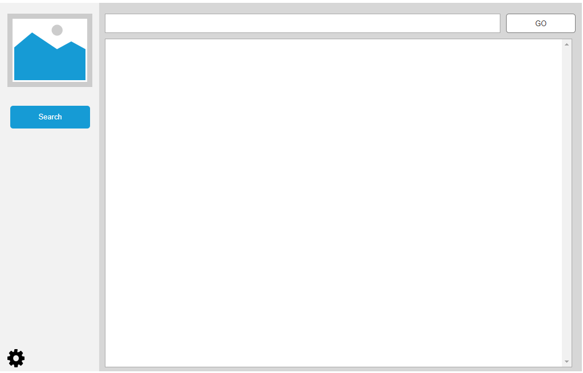

*Before sign in*

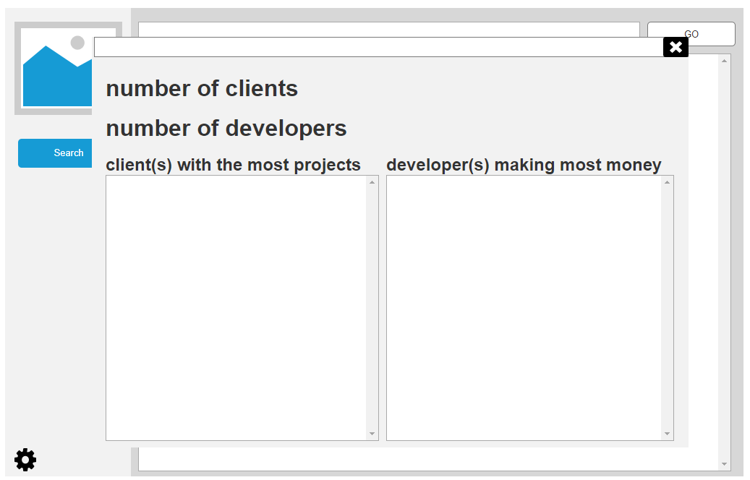

*View Statistics*

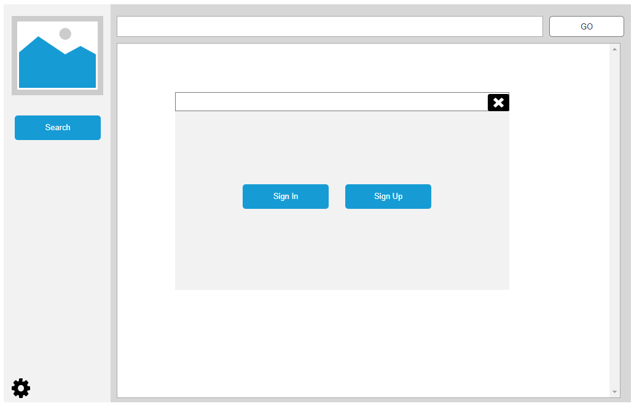

*Sign in and sign up*

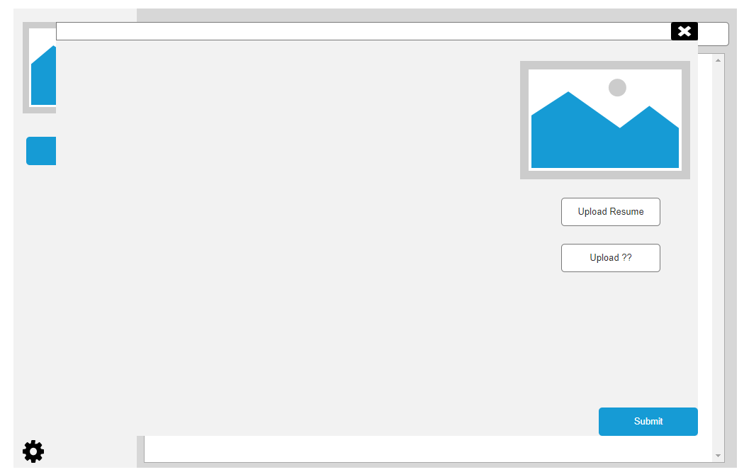

*sign up*

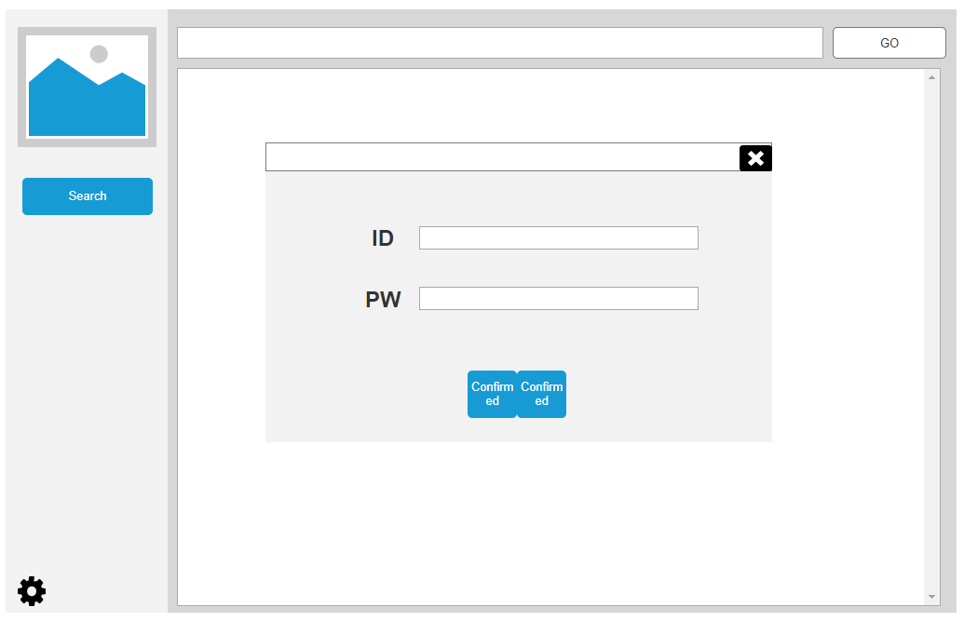

*sign in*

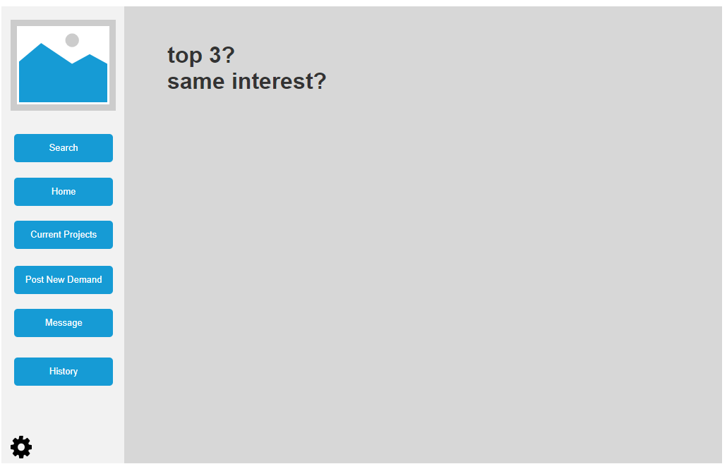

*sign in as a client*

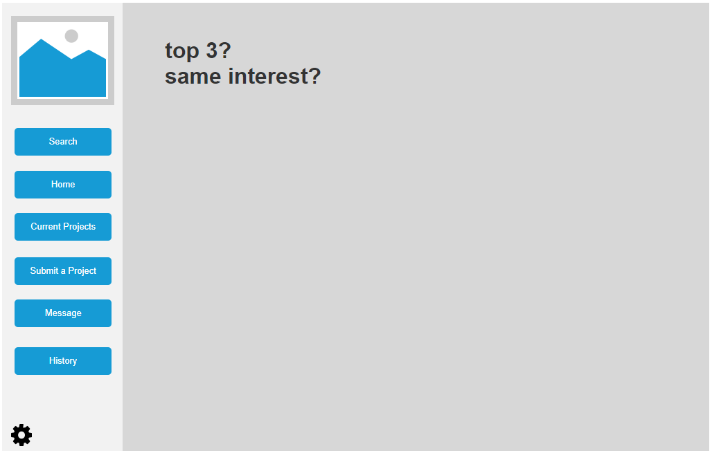

*sign in as a develop*

# **Minutes of group meetings**

Friday 11am - 6 pm

# **Minutes of group meetings**

down the corrected version via link <https://github.com/whuang001/cts/tree/Weicheng/docs>